Full Stack Web Development

Gokboru Tech pvt ld.
A training report

Submitted in partial fulfilment of the requirements for the award of degree of
Bachelor Of Technology
(Computer Science and Engineering)
Submitted to
LOVELY PROFESSIONAL UNIVERSITY

PHAGWARA, PUNJAB

From 06/06/24 to 07/18/24

SUBMITTED BY
Name of student: G. Prince Nihal
Registration Number: 12212377
Signature of the student: princenihal

To whom so ever it may concern
I, G. Prince Nihal, 12212377, hereby declare that the work done by me on “Gym website ” by using front-end Frame Work from 06, 2024 to 07, 2024, is a record of original work for the partial fulfilment of the requirements for the award of the degree, Computer Science And Engineering.

Name of the Student: G. Prince Nihal
Registration Number: 12212377

Signature of the student: Guzzarlapudi Prince Nihal
Dated: 13/02/2025

Certificate Issued By Organization:-



INTRODUCTION:-
During my summer training, I had the opportunity to delve into the world of web development with a focus on and Node.js. These technologies are at the forefront of modern web development, enabling the creation of dynamic and responsive user interfaces. In this report, I will provide an overview of the key topics I covered during the training, highlighting the essential concepts and skills I acquired.
In today's fast-paced world, the demand for convenient gym services has reached unprecedented heights. With the hectic lifestyles and the ever-increasing reliance on technology, online gym platforms have become an integral part of our daily lives. As part of our commitment to exploring cutting-edge technologies and delivering practical solutions, i proudly present my project –a gym website built using js.

Project Overview:-
Our Gym website is a web-based application designed to replicate the essential functionalities of the popular gym service, Gym website. Leveraging the power of js, a versatile and widely-used JavaScript library for building user interfaces, we aim to deliver an intuitive, responsive, and feature-rich platform that allows users to browse types of exercises, select memberships, place bookings.

Key Features:-
User Registration and Authentication: Just like the original Gym website, my website allows users to create accounts and log in securely. User authentication ensures a personalized experience and history tracking.
- Gym Listings: Users can explore the fitness types in their vicinity. Detailed Gym profiles provide information about types of exercises, ratings, timings, and more. Menu Display: The application displays gym’s menu in a user-friendly format.
Users can browse memberships, view prices, and read descriptions before making selections.
- Cart Management: This feature allows users to add and remove items.
- User Reviews and Ratings: Users can leave reviews and ratings for gyms, contributing to a community-driven feedback system.

Technology Stack:-
Our Gym website is built using a robust technology stack, with js as the front-end framework, ensuring a smooth and responsive user interface. We utilize state management libraries like Redux for efficient data flow and Axios for handling API requests. Additionally, we employ modern CSS frameworks for elegant and responsive design.

JS:-
JS has been chosen for its flexibility, component-based architecture, and vibrant ecosystem of libraries and tools. These qualities make it an ideal choice for developing interactive and dynamic web applications like our Gym website.

Project Goals:-
Our primary goal is to provide an open-source alternative to popular Gym platforms, allowing users to set up their own fitness services or gain insights into .js development by studying our codebase.
Stay tuned as we delve into the details of our Gym website project, showcasing its architecture, implementation, and the valuable lessons we've learned along the way.
Join us on this exciting journey of building a Gym website with js, where innovation meets practicality in the world of online gym booking facilities.

OBJECTIVES:-
Creating a Gym website using the js framework involves several objectives to ensure the successful development of the project. Here are the key objectives:
- Replicate hrx User Experience: The primary objective is to mimic the user experience provided by hrx. This includes creating an intuitive and user-friendly interface for browsing exercises, selecting memberships, and reviews.
- Responsive Design: Ensure that the application is responsive and works seamlessly across various devices to join gym a wide range of users.
Membership Display: Create a visually appealing and easy-to-navigate exercises display for each cardio and zumba, allowing users to view in detailed, prices, and dietary information.
- User Reviews and Ratings: Allow users to leave reviews and ratings for gym and memberships, promoting transparency and helping others make informed decisions.
- Admin Dashboard: Create an admin dashboard for gym owners and contact personnel to manage plans, update membership.
- Scalability: Design the application architecture with scalability in mind, allowing for easy expansion to accommodate a growing user base and additional features.
- Documentation: Create comprehensive documentation for developers, including code comments, setup instructions, and API documentation if applicable.
- Testing and Quality Assurance: Conduct thorough testing, including unit testing, integration testing, and user acceptance testing, to identify and resolve any bugs or usability issues.
- Community Engagement: If open-source encourage community engagement by welcoming contributions from other developers and providing support through forums or documentation.
- User Feedback and Iteration: Continuously gather user feedback and iterate on the application to improve its features, performance, and user satisfaction.

SCOPE OF THE PROJECT:-
Front End web Development has a significant and beneficial scope in a Gym website project. It offers a powerful and flexible framework for building the user interface (UI) and can enhance various aspects of your gym clone, making it a popular choice for such applications. Here's the scope of
.js in a gym website project:-
User Interface Development: 's component-based architecture makes it ideal for developing complex user interfaces, which are a central element of any gym app like Hrx. You can create reusable UI components for various parts of your app, such as gyms listings, menus, shopping carts, and booking status.
- Real-time Updates: 's ability to efficiently update and re-render components when data changes is crucial for real-time features like tracking the status and updating the cart total without reloading the page.
- Responsive Design: can help you build a responsive design that adapts seamlessly to different screen sizes and devices, ensuring a consistent and userfriendly experience for customers on desktop.
- State Management: 's state management, in conjunction with libraries like Redux or Context, allows you to manage the application's state effectively. This is essential for handling user authentication, shopping cart contents.
- Integration with RESTful APIs: You can easily integrate with RESTful APIs to fetch and display data, such as gym information, memberships, and user profiles, ensuring that your Gym website has up-to-date content.
Third-party Libraries: has a vast ecosystem of third-party libraries and components that can be leveraged to enhance your app's functionality, such as integrating maps for adding payment gateways for seamless transactions.
- Code Reusability: promotes code reusability through component composition, making it easier to maintain and scale your application as you add new features or expand to different markets.
- Testing: has strong support for testing, allowing you to write unit tests and integration tests for your components and ensuring the reliability and stability of your Gym websites.
- Community and Resources: has a large and active community, which means you can find ample resources, documentation, and open-source projects to assist in the development of your gym websites. You can also seek help from experienced developers through forums and communities.
- Cross-platform Development: can be used for cross-platform development. You can potentially reuse some of your components and logic when building a mobile app version of your gym websites using Native.

FEATURES OF JS :-
When building a gym website using .js, several features of are particularly useful and relevant to create a dynamic and interactive user interface for your gym website. Here are some key .js features that are commonly used in a gym websites:
Component-Based Architecture: 's component-based architecture is central to building the various parts of your Gym website app.
Virtual DOM: 's Virtual DOM helps optimize the app's performance by efficiently updating the real DOM only when necessary. This is crucial for rendering dynamic content like plans, exercises ,memberships.
JSX (JavaScript XML): JSX allows you to write HTML-like code within your
JavaScript files. This is useful for defining the structure and layout of your app's user interface.
- State and Props: Managing component state and passing data through props are fundamental concepts. You'll use state to handle dynamic data like shopping cart contents and user authentication status. Props enable you to pass data from parent to child components.
- Event Handling: makes it straightforward to handle user interactions such as button clicks, form submissions, and menu item selections.
- Conditional Rendering: You'll often conditionally render components or elements based on user actions or application state.
- Lists and Keys: Displaying lists of items, like gyms listings and menu items, involves mapping through arrays and using keys to optimize rendering performance.
Forms and Controlled Components: Building forms for user input, such as delivery addresses and payment information, relies on controlled components to manage form data and user interactions.
- Conditional Styling: You'll apply styles dynamically based on component state or user interactions, ensuring a visually appealing and user-friendly experience.
- Error Handling: Handling errors, especially during network requests or user interactions, is crucial for providing a smooth and reliable user experience.

APPLICATIONS OF JS:-
JS, a library for building user interfaces, has a wide range of applications. Some of the common use cases include:
- Single-page Applications (SPA): is commonly used to build SPAs where content is dynamically updated without the need for full page reloads. It allows for a fast and smooth user experience.
- Interactive User Interfaces: 's virtual DOM (Document Object Model) and component-based architecture make it easy to create interactive user interfaces. enables developers to build reusable UI components that can be rendered and updated efficiently.
- Real-time Data Updates: is often used in applications that require real-time updates, such as chat applications, messaging platforms, and collaborative tools. It can efficiently update the DOM and display data changes in real-time with minimal performance impact.
- Data Visualization: can be used in combination with libraries like D3.js to create interactive data visualizations. 's component-based architecture allows for easy integration and manipulation of data visualizations in the UI.
- Progressive Web Apps (PWA): can be used to develop PWAs, which are web applications that provide a native app-like experience to users. PWAs can be accessed through web browsers and installed on users' devices, allowing offline access and push notifications.
- E-commerce Platforms: 's component-based architecture makes it easy to develop and manage complex e-commerce platforms. 's ability to efficiently handle large amounts of data, its support for server-side rendering, and its vast ecosystem of libraries and tools make it a popular choice for building online shopping websites.

These are just a few examples of the many applications of JS. flexibility, performance, and extensive ecosystem make it applicable in a wide range of web and mobile development scenarios.
There are many companies or organizations that use JS for building their projects.
Some of the notable companies include:
  - Facebook: JS was developed by Facebook, and they extensively use it for various projects including the Facebook website and mobile apps.
  - Instagram: Instagram, which is owned by Facebook, also uses JS for its web interface and mobile app.
  - Netflix: Netflix uses JS for building its user interface, making it fast and responsive.
  - Airbnb: Airbnb uses JS to build its frontend interface for both web and mobile applications.
  - WhatsApp: WhatsApp, which is also owned by Facebook, uses JS for its web interface.
  - Dropbox: Dropbox uses JS for building its web applications to provide a seamless user experience.
  - Lyft: Lyft uses JS for building their web and mobile applications to provide a smooth user experience for their customers.
  - Atlassian: Companies like Atlassian, known for their project management tools like JIRA and Trello, use JS extensively for their frontend development.
  - Microsoft: Microsoft uses JS for projects like Office 365 and Outlook.com to create a modern and responsive user interface.
These are few examples, but JS is widely adopted by companies of all sizes across different industries to build performant and scalable web and mobile applications.

PROJECT DETAILS AND CODING:-

ICONS:-Gym Website

Project Overview
This report provides an overview of the development of a gym website using JS as the front-end framework. The website is designed to offer an intuitive and responsive user experience, showcasing various aspects of the gym such as its services, classes, membership plans, and more. The key components and pages included in the website are Home, Index, About, Classes, Contact, Membership, style.css, and index.js.

1. Home Component
- Purpose: The Home component serves as the landing page for the gym website. It is designed to make a strong first impression with a welcoming layout that introduces users to the gym's core offerings.
- Content: The Home page typically includes a hero section with an eye-catching image or video, a brief overview of the gym’s mission, and quick navigation links to other key sections of the website.
- Features: Call-to-action buttons leading to other pages (e.g., "Join Now", "Explore Classes"), a navigation bar, and possibly a testimonials section.

2. Index Component
- Purpose: The Index component in this context likely acts as the root component or entry point for the application. It is responsible for rendering the primary structure of the website, including the routing and layout.
- Content: The Index component might include the main navigation, footer, and routes to various pages like Home, About, Classes, etc.
- Features: Router is usually implemented here to manage the navigation between different pages without reloading the site.
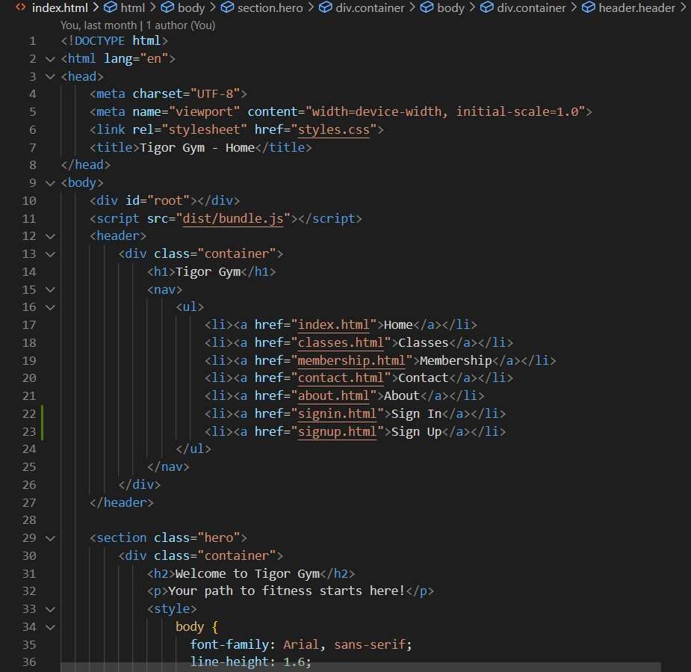
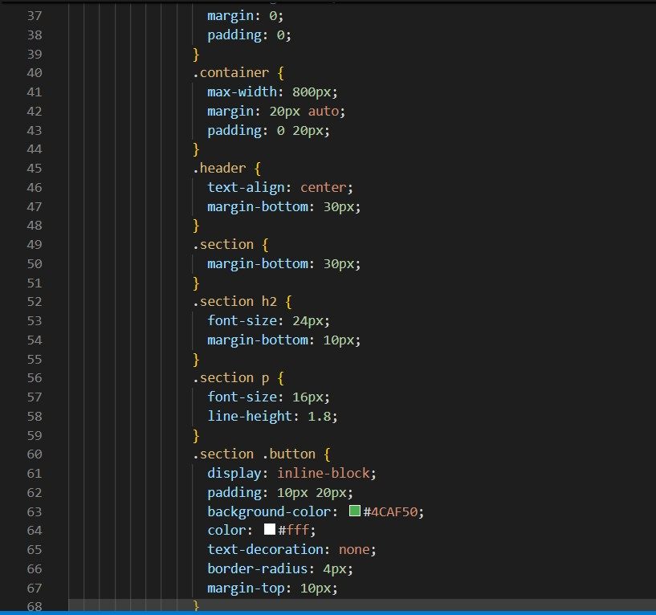

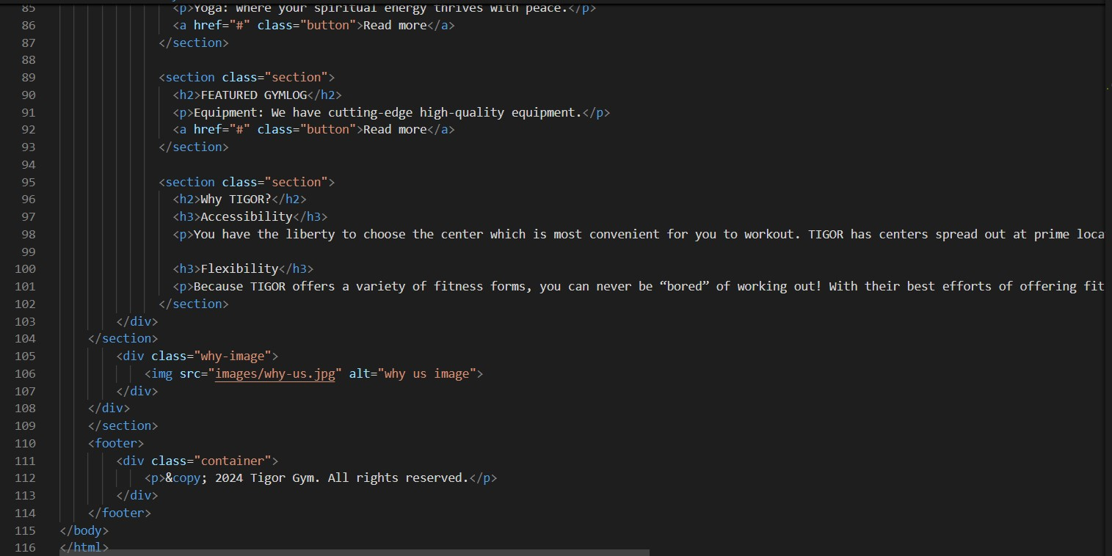

3. About Component
- Purpose: The About component provides detailed information about the gym, its history, mission, vision, and the team behind it.
- Content: This page often contains sections like the gym’s story, a message from the founder, and possibly a gallery of images showcasing the gym’s facilities.
- Features: Team members' profiles with images and brief bios, mission and vision statements.
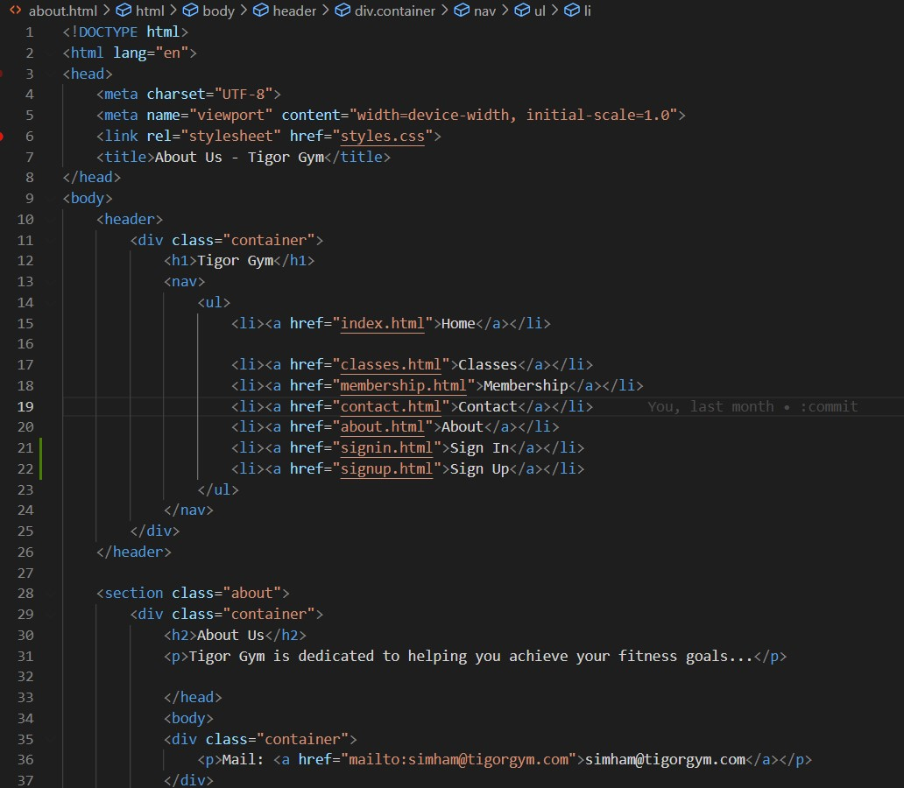
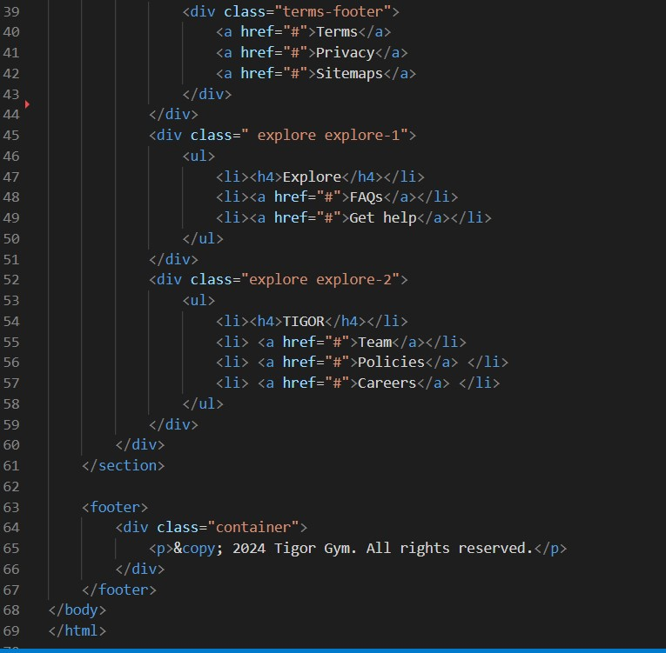

4. Classes Component
- Purpose: The Classes component is dedicated to showcasing the various fitness classes offered by the gym.
- Content: This page includes a list or grid of classes, each with a brief description, schedule, and the trainer's name.
- Features: Filtering options based on class type (e.g., Yoga, Pilates, Strength Training), class schedules, and the ability to book or join a class directly from the page.
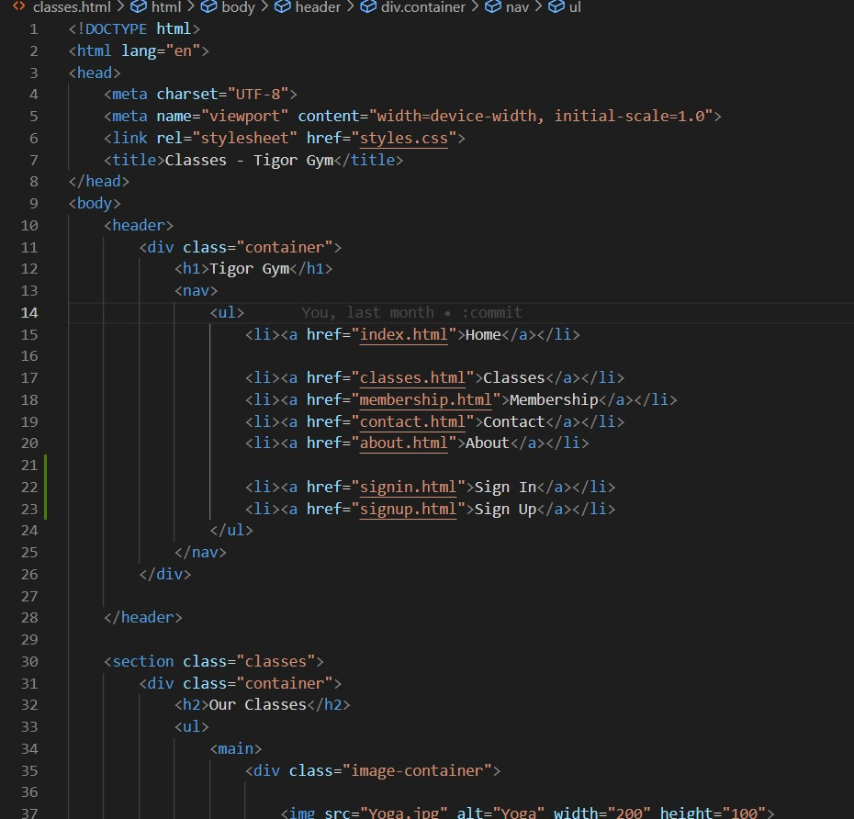

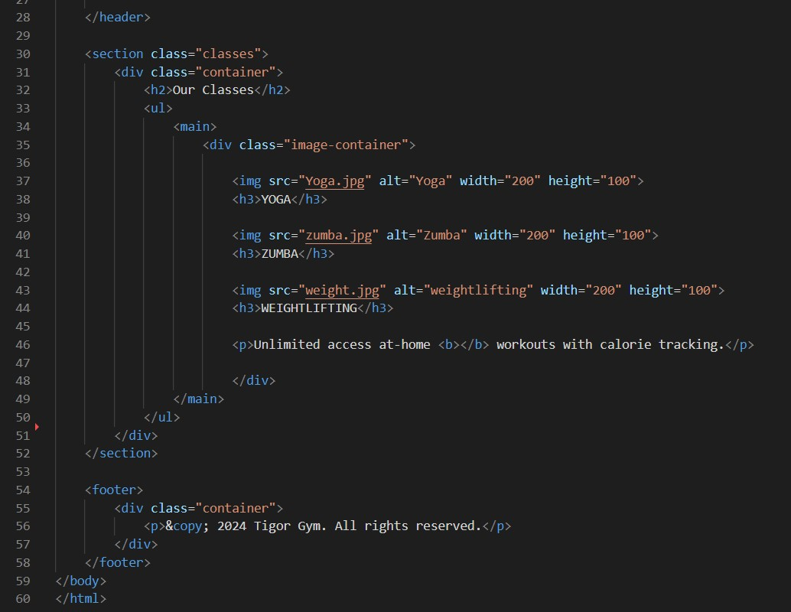

5. Contact Component
- Purpose: The Contact component is where users can find information on how to reach out to the gym.
- Content: This page includes a contact form, gym location, phone number, email address, and possibly a map showing the gym’s location.
• 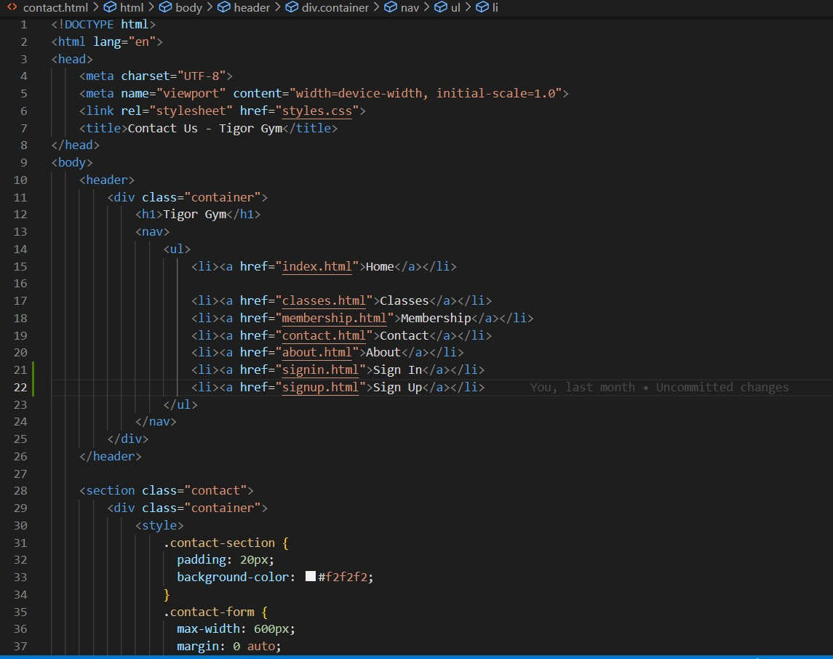
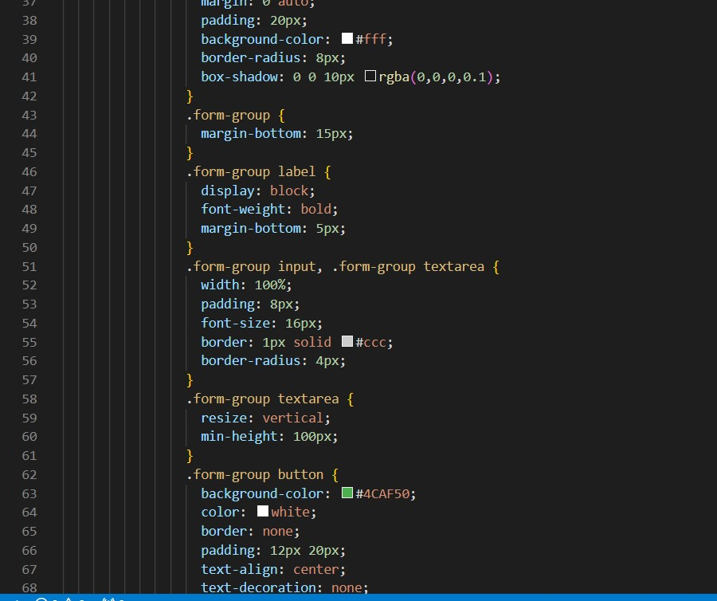
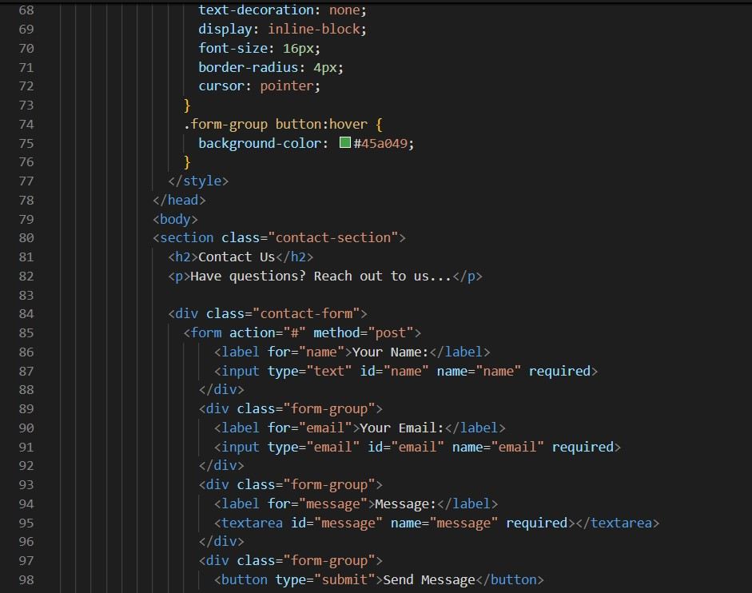
Features: A functional contact form that can be integrated with an API to handle form submissions, gmail,,facebook , whats app integration for displaying the gym’s
contact.
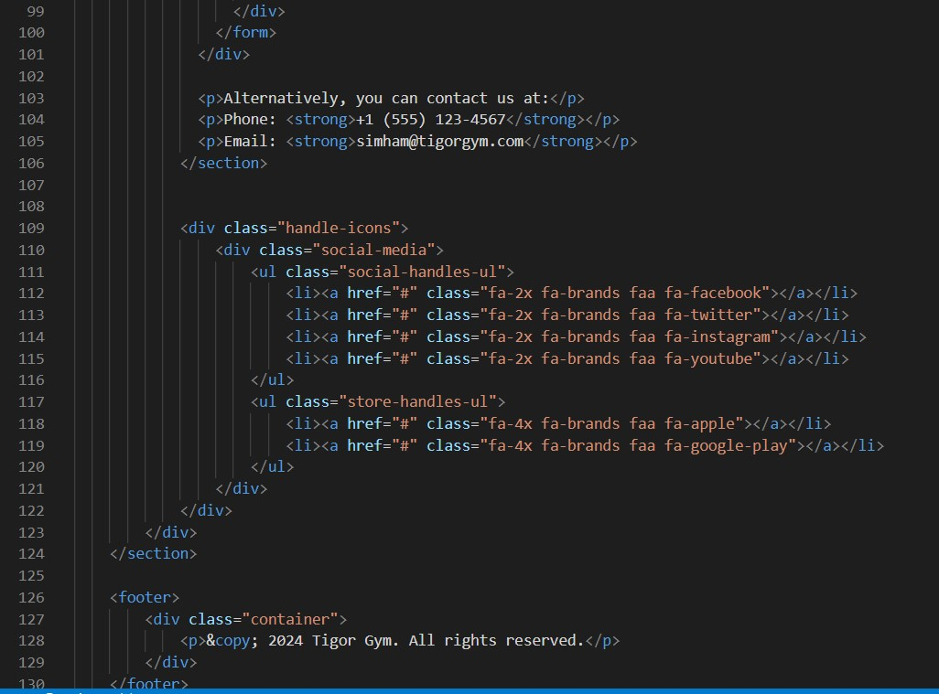

6. Membership Component
- Purpose: The Membership component is designed to provide users with information about different membership plans and allow them to sign up.
- Content: This page includes a comparison of various membership plans (e.g., Basic, Premium, VIP), pricing details, and benefits associated with each plan.
- Features: Plan comparison tables, a sign-up or purchase button that might link to a payment gateway or a registration form.
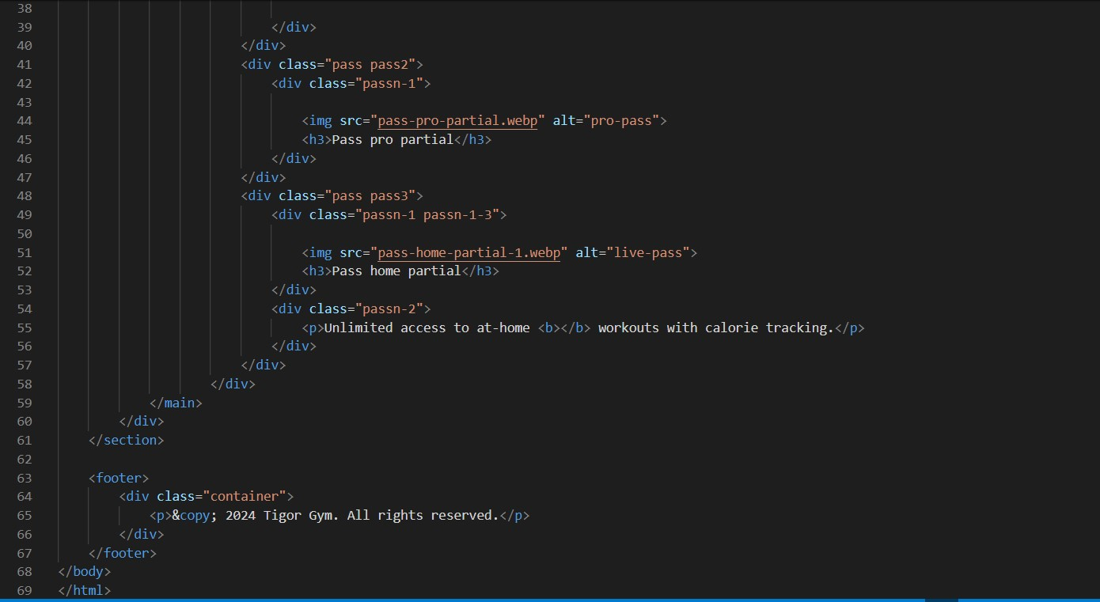
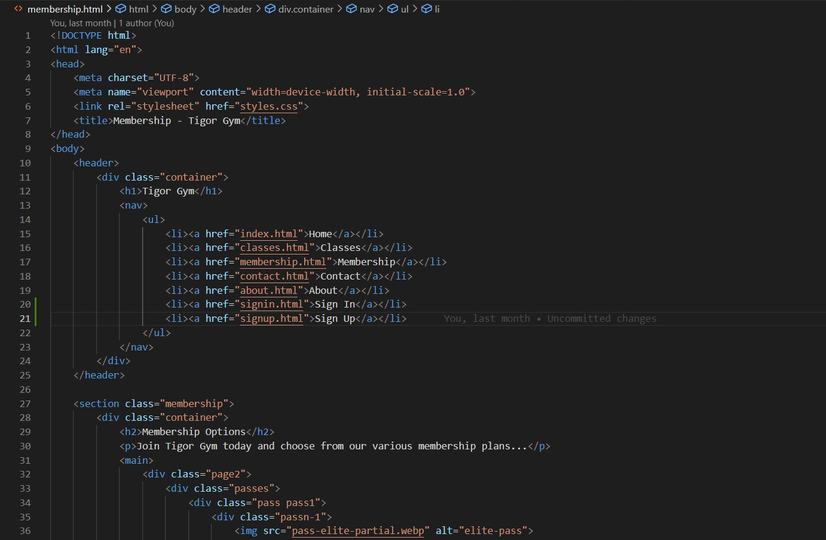
•

7. style.css
- Purpose: The style.css file is responsible for the overall styling of the website. It contains the CSS rules that define the appearance of all the components mentioned above.
- Content: This file includes styles for layout (e.g., grid, flexbox), typography, colors, buttons, and responsiveness.
- Features: Media queries for making the site responsive across different devices, custom classes for styling specific components, and possibly animations or transitions.
• 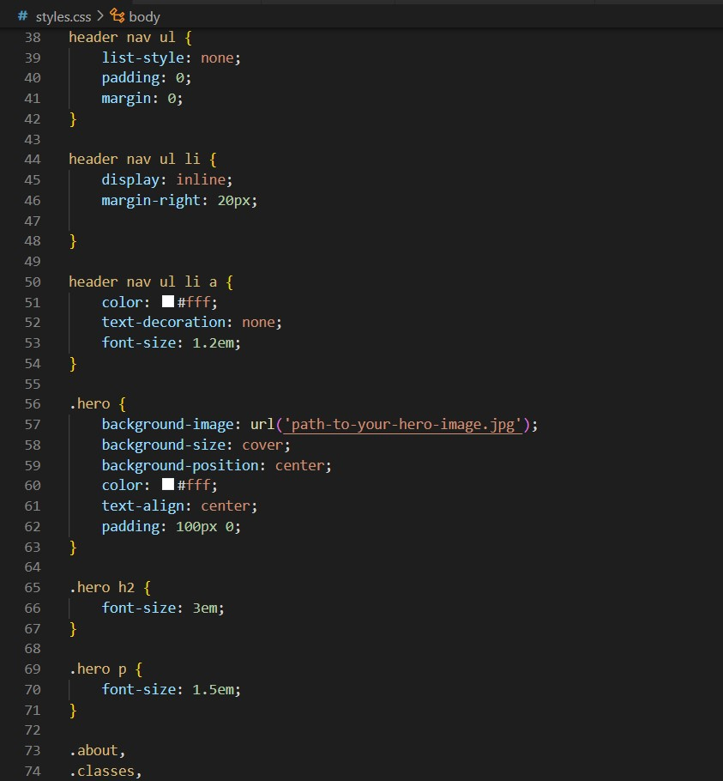
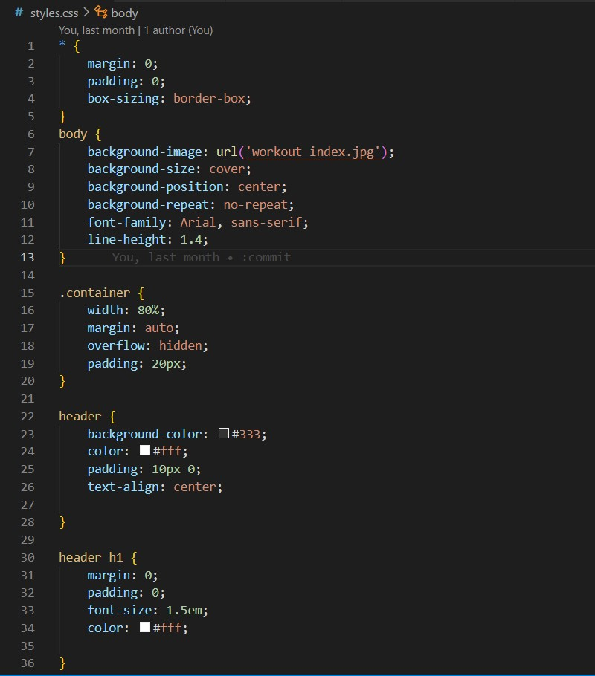
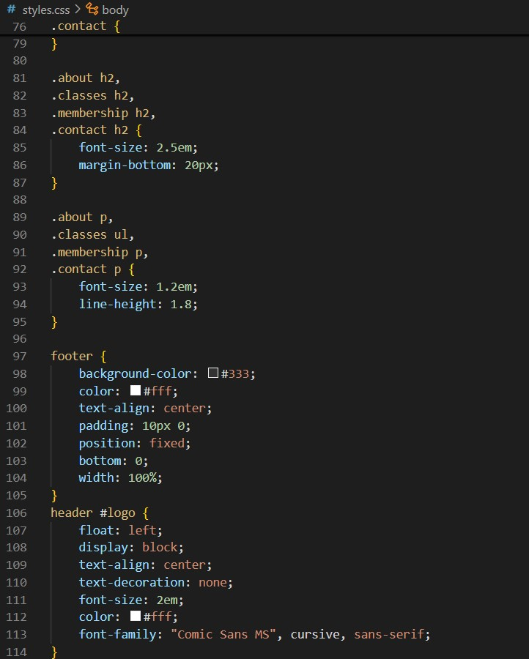

8. index.js
- Purpose: The index.js file is the entry point of the application. It is responsible for rendering the app and integrating it with the HTML DOM.
- Content: This file imports DOM, and the root component (often App.js), and renders the application into the root element of the HTML file.
- Features: This file also sets up the Router, if used, and includes any global configurations or providers, such as context providers or state management tools like Redux.
- 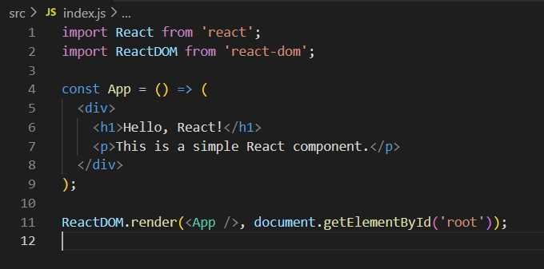

Conclusion
The gym website developed using JS is structured to offer a comprehensive and user-friendly platform for potential and existing members. Each component is designed with a specific purpose, contributing to the overall functionality and aesthetics of the site. The use of style.css ensures a consistent look and feel across the site, while index.js ties everything together, making it a cohesive and interactive web application.
This project demonstrates the effective use of modern web development practices, focusing on both user experience and maintainability.

There are several icons that can be used in a Gym website built with JS. Here are some commonly used icon libraries in JS projects:.

CONCLUSION:-
In conclusion, the Full-stack Web Development course has been an enriching and transformative journey for both aspiring and seasoned developers alike. Throughout this course, participants have delved into the intricacies of modern web development, gaining a comprehensive understanding of the application in building dynamic, interactive user interfaces. The course has equipped students with the skills and knowledge required to become proficient full-stack developers, capable of handling both the frontend and backend aspects of web applications.
One of the stand out highlights of this course has undoubtedly been the Gym website project. This real-world, hands-on project allowed students to put their newly acquired skills into practice by creating a fully functional web application that closely mimics the popular gym platform hrx. Through the Gym website project, participants honed their abilities in frontend development with JS, backend development with technologies like Node.js and Express, and database management with MongoDB or other database systems.
Key takeaways from the Gym websites project include:
- Application of JS: Students gained a deep understanding of JS, using it to build the user interface of their Gym website. They learned about components, state management, and how to create responsive and intuitive web pages.
- Backend Development: The project enabled students to explore server-side development using Node.js and Express. They learned to handle requests and responses, set up APIs, and implement the necessary server logic.
- Authentication and Authorization: Security is paramount in web development, and students gained insight into implementing user authentication and authorization features, ensuring data privacy and user access control.
- Deployment: The course covered the process of deploying web applications, giving students the knowledge to make their projects accessible to users on the web.
- Project Management: Beyond technical skills,i learned about project management, including task planning, version control, which are crucial for success in real-world development environments.
Overall, the Gym website project not only showcased the technical prowess of the course participants but also instilled in them the confidence to tackle complex projects and contribute to the ever-evolving field of web development. As these developers continue to grow and apply their skills, they are well-equipped to create innovative and user-centric web applications that can have a significant impact on the digital landscape.
In conclusion, the Fullstack Web Development course, along with the Gym website project, has been a comprehensive and valuable learning experience. It has empowered participants with the knowledge and practical skills needed to excel in the field of web development, fostering a new generation of developers ready to build the next generation of web applications.
OUTPUT OF THE PROJECT

Project Overview
This report provides an overview of a gym website developed using the front-end framework. The website features various components, each designed to enhance the user experience and provide essential information about the gym. The primary components include Home, Index, About, Classes, Contact, and Membership. Additionally, the project utilizes style.css for styling and index.js for application setup and rendering.

1. Index Component:
• Description: The Index component acts as the central hub of the application. It sets up the routing for the website, allowing users to navigate between different pages like Home, About, Classes, Membership, and Contact without reloading the entire page. It also typically includes the main layout structure, such as the header, footer, and navigation bar.

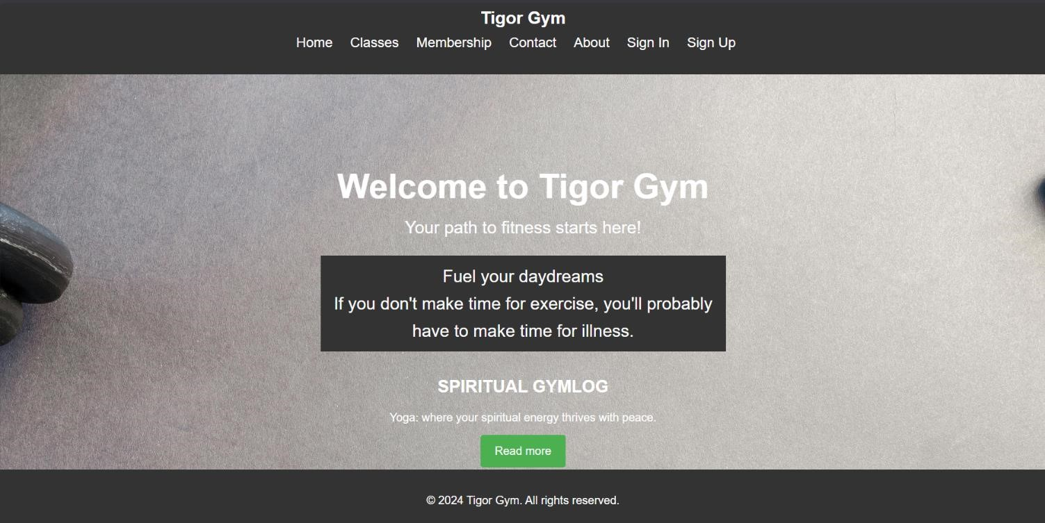

2.Classes Component
• Description: The Classes component provides detailed information about the various fitness classes offered by the gym. Each class listing includes the class name, a brief description, the schedule, and the instructor's name. Users can explore different classes and find the ones that best suit their fitness goals. This component might also include filters to sort classes by type, intensity, or schedule.

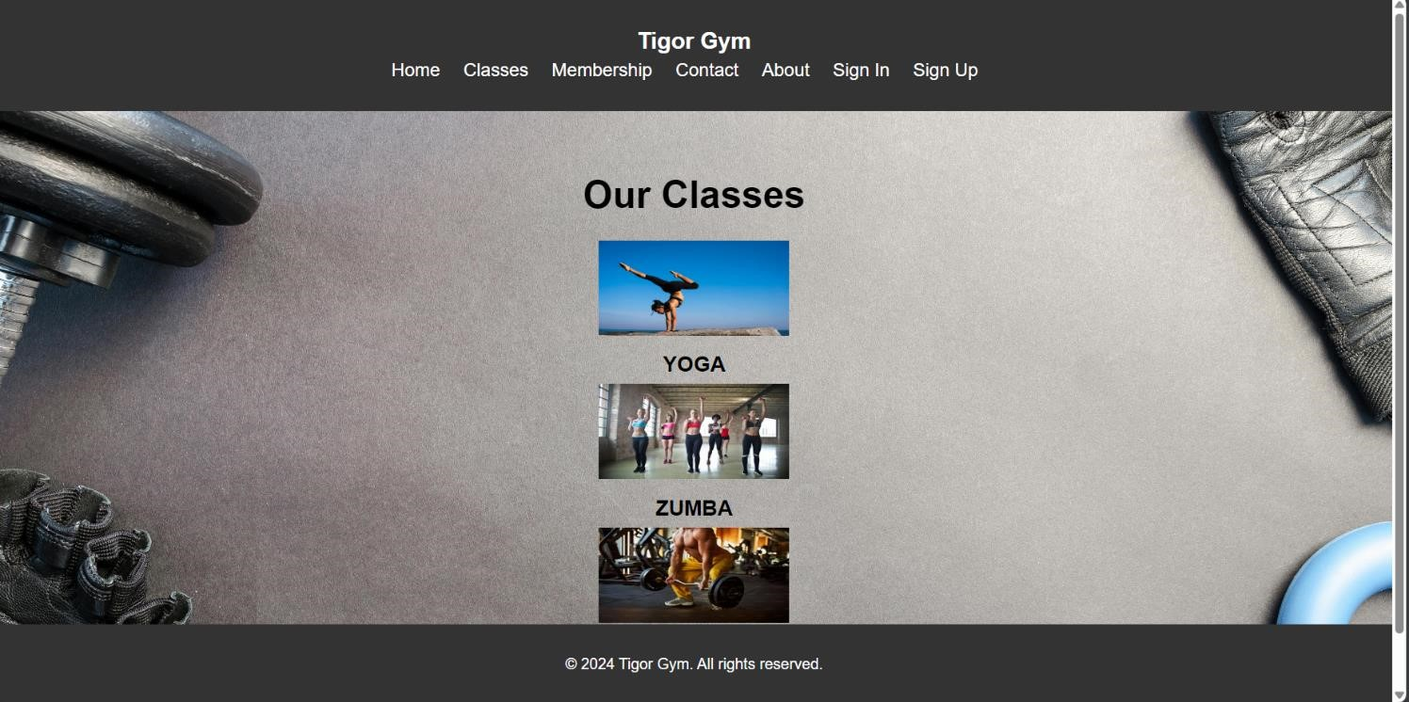

3.Membership Component
• Description: The Membership component outlines the different membership plans available at the gym. Each plan includes details such as pricing, benefits, and terms. Users can compare the plans and choose the one that best fits their needs. The component may also include a sign-up or registration form, linking to payment options or further steps in the membership process.

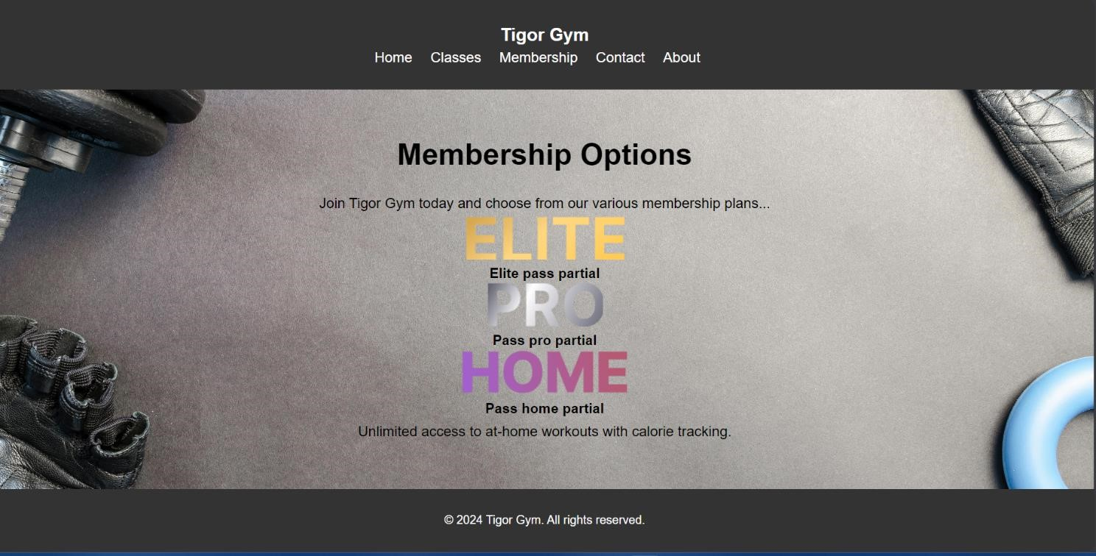

4.Contact Component
• Description: The Contact component includes essential contact information for the gym, such as the address, phone number, and email. It also features a contact form that allows users to send inquiries or feedback directly through the website. Additionally, a map integration may be included to help users find the gym's location.

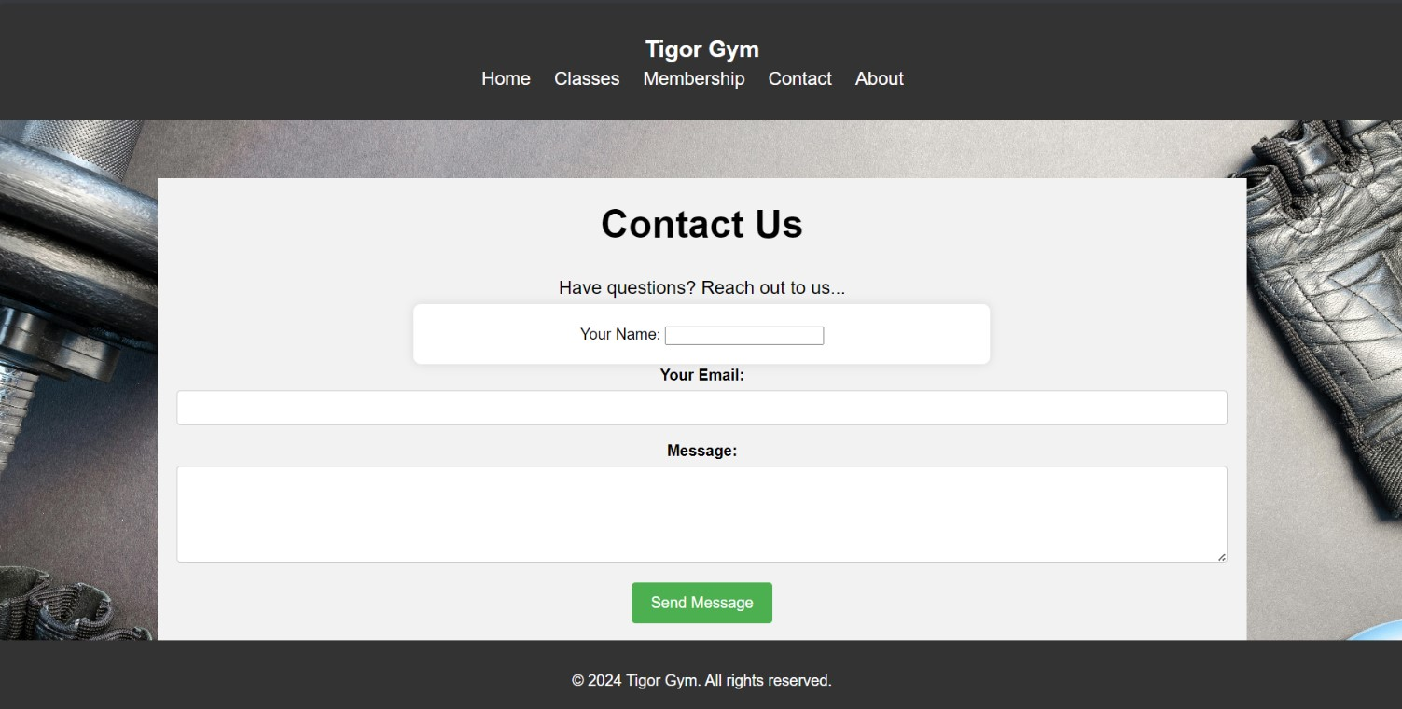

5.About Component
• Description: The About component gives a detailed overview of the gym, including its mission, vision, and history. It may also include information about the gym's founders, key team members, and their qualifications. This section aims to build trust and credibility with potential members by showcasing the gym's values and expertise.

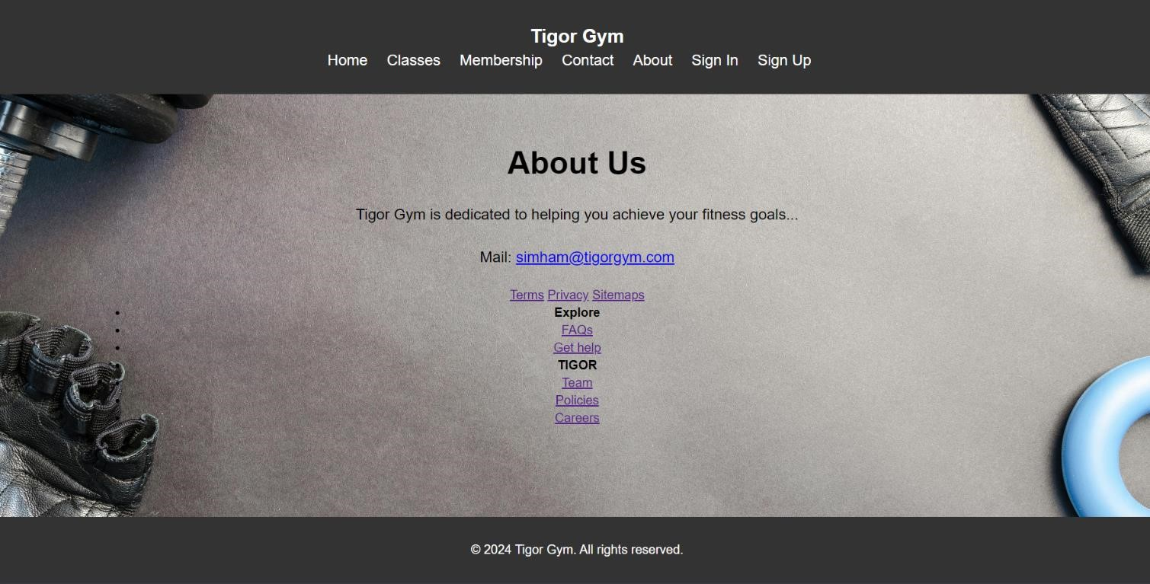

Total Output of the Project
The gym website project is a fully functional and responsive web application that offers users a comprehensive overview of the gym's services, classes, membership options, and more.
The key features of the project include:
- Navigation: Seamless navigation between different sections (Home, About, Classes, Membership, Contact) through a well-structured routing system.
- Responsive Design: The site is fully responsive, ensuring a smooth user experience across various devices, including desktops, tablets, and mobile phones.
- User Interaction: Users can explore class schedules, compare membership plans, and contact the gym directly through integrated forms.
- Styling: The style.css file ensures consistent and attractive styling throughout the website, enhancing the overall user experience.
- Clean Code Structure: The use of JS components promotes a clean, modular code structure, making the website easy to maintain and update.
This project demonstrates proficiency in JS development, showcasing the ability to create an engaging, user-friendly, and responsive web application for a gym or fitness center.

REFERENCE :-

Gokboru tech pvt ltd: Full Stack Web Development
- Official Documentation: The official documentation is always a great place to start. It provides comprehensive information, tutorials, and examples for js.
- JS Tutorial: The official JS website offers a step-by-step tutorial that helps beginners understand the core concepts of JS.
- JS GitHub Repository: You can explore the .js source code and open issues or contribute to the project on its GitHub repository.



